React Native Installation

Refernce Link : <https://reactnative.dev/docs/environment-setup?guide=native>

<https://microsoft.github.io/react-native-windows/docs/getting-started>

Step 1

Install Android Studio

Link :

<https://developer.android.com/studio?gclid=CjwKCAjw7c2pBhAZEiwA88pOF1p8PGLzgLk_snhqkWjdEJOD0rVqVztAXhOqIcDW6MHseqD4f4Yn7hoCSM0QAvD_BwE&gclsrc=aw.ds>

install completely and create 1 android project

and run on physical device

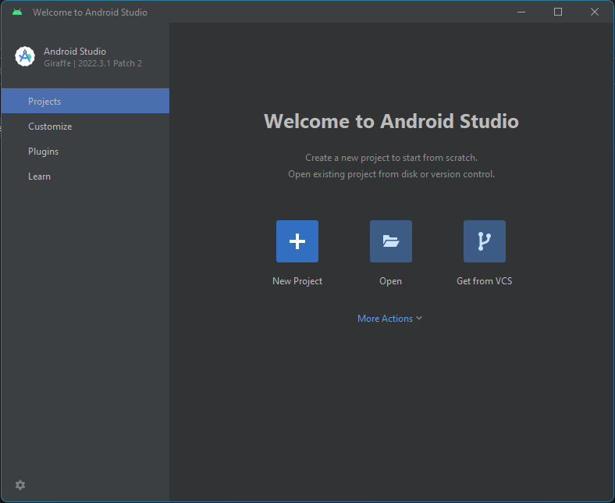

Create a Android project in java

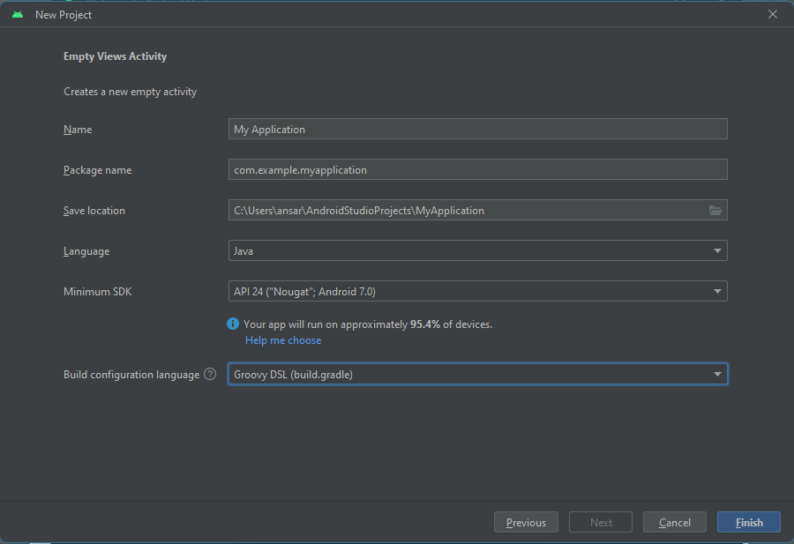

And click on Finish

Goto Your android Phone and enable Developer Option

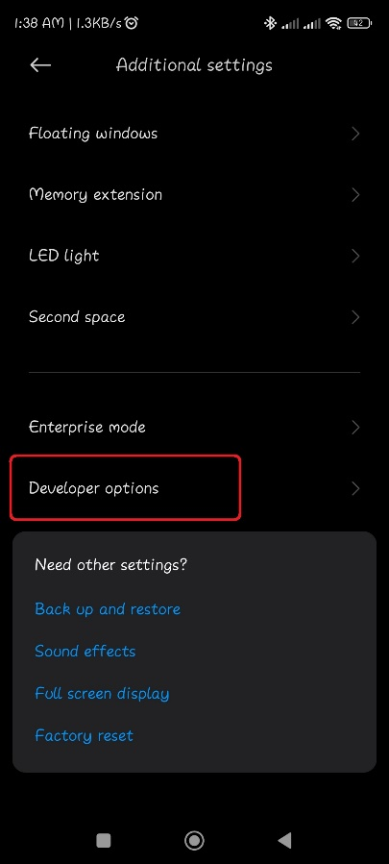

Enable Usb Debugging option

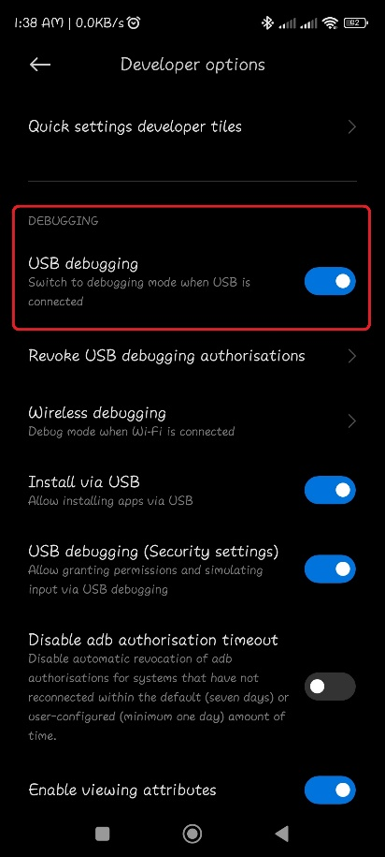

Wait android Studio to finish indexing ( right botton ) in android studio

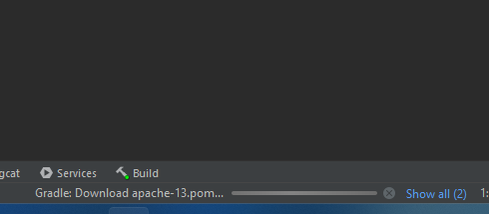

After Complete Indexing ,connect your android via usb

And click on

Device option (Top right side in android studio )

Then click on Phycical Device & check Your Device is available or not

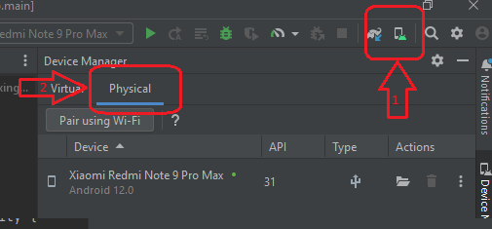

If its visible then run the app

After Successful installation of android app move to next step

Step 2

Install Chocolatey

Reference Link : <https://chocolatey.org/install>

Open Windows PowerShell in andministrator Mode

And Past this command

>>> Set-ExecutionPolicy Bypass -Scope Process -Force; [System.Net.ServicePointManager]::SecurityProtocol = [System.Net.ServicePointManager]::SecurityProtocol -bor 3072; iex ((New-Object System.Net.WebClient).DownloadString('https://community.chocolatey.org/install.ps1'))

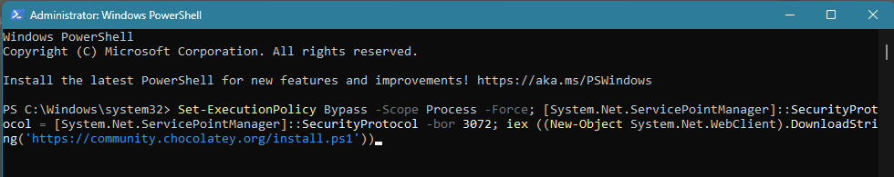

To check Chocolatey is installed or not run below command in powerShell

>>> choco

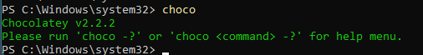

Step 3

install node and java

Open new PowerShell in administrator Mode

And run this command ( this command will install node and Java 11 )

>>> choco install -y nodejs-lts microsoft-openjdk11

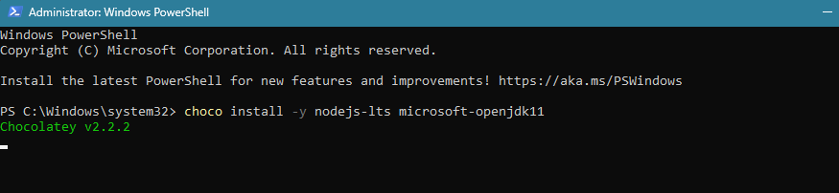

To check node and java

Again open new powerShell

>>> node –version

>>> java -version

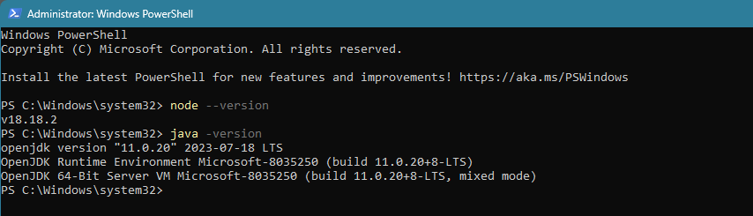

Step 4

Configure the ANDROID_HOME environment variable ( user )

Locate SDK path

In my case

C:\Users\ansar\AppData\Local\Android\Sdk

Configure

Press windows key and search ( environment variable )

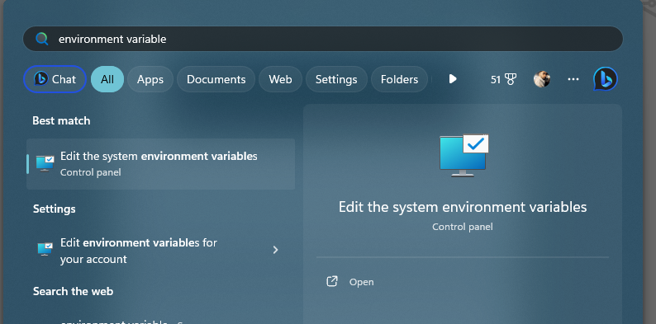

And open

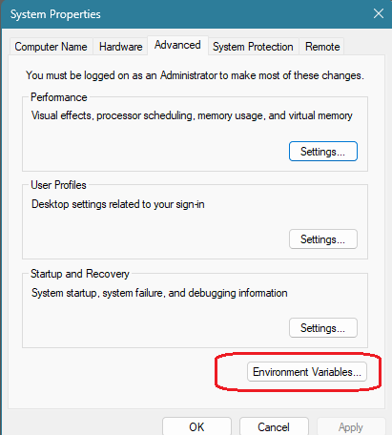

Click on new

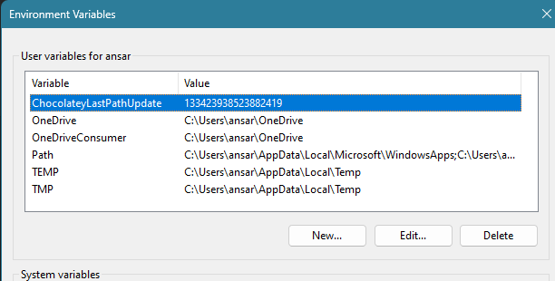

And add

ANDROID_HOME

C:\Users\ansar\AppData\Local\Android\Sdk

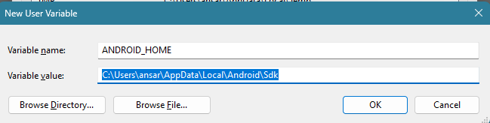

Press Ok

Now goto sdk path

And copy platform-toolspath

C:\Users\ansar\AppData\Local\Android\Sdk\platform-tools

And open System variable path (double click on path )

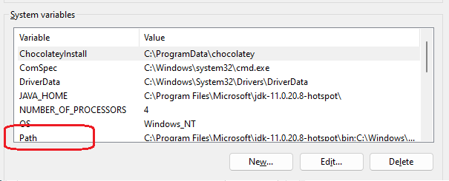

click new and add platform-tools path

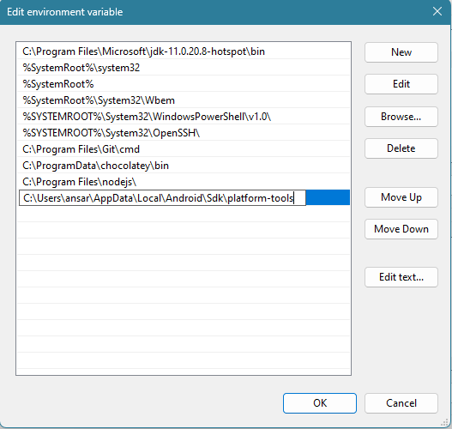

And press ok and save environment variable

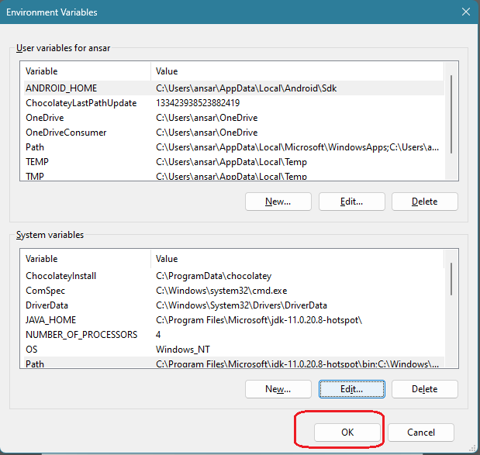

Press ok

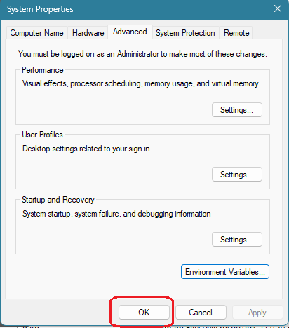

Move to next step

Step 5

Install Dependencies on android SDK

Open android Studio and goto settings (top right )

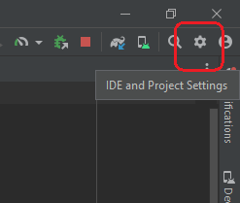

Open SDK Manager

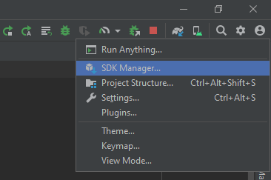

Check these options in SDK Platform

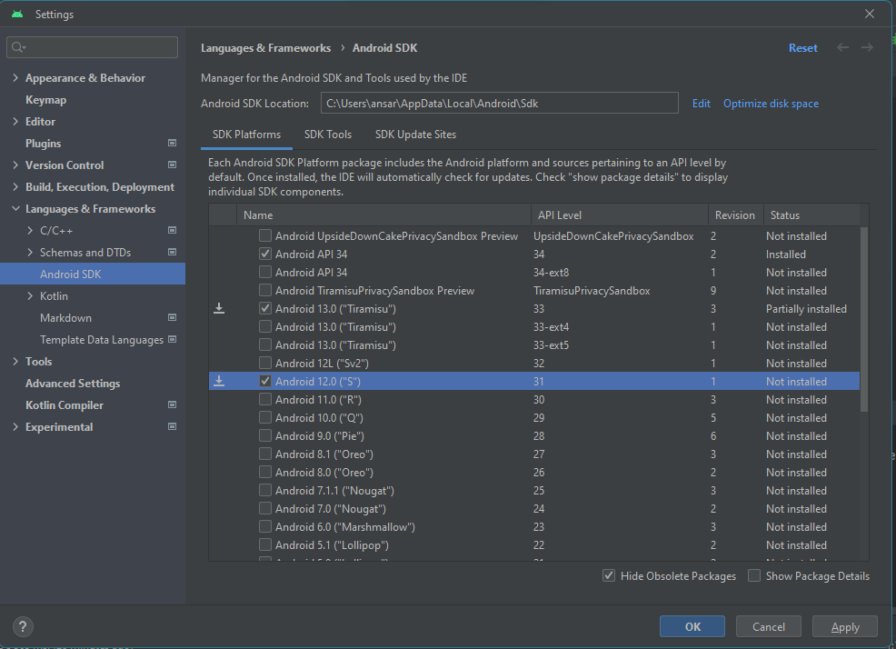

Switch tab to SDK Tools and Check these options

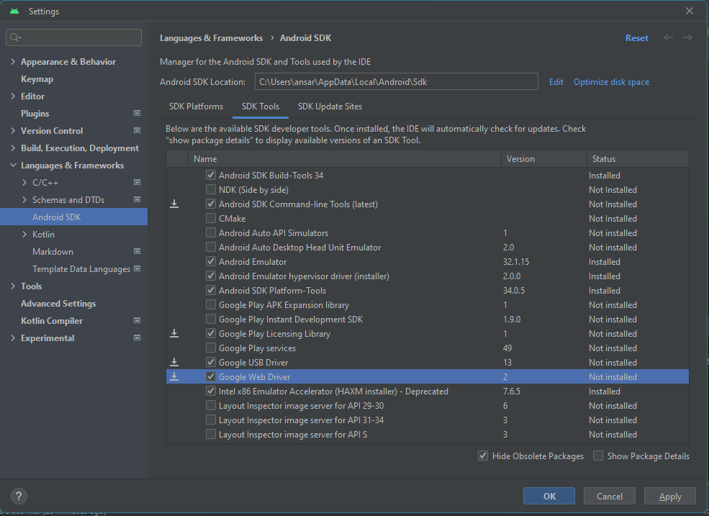

And press Apply Button

And press Ok to download dependencies

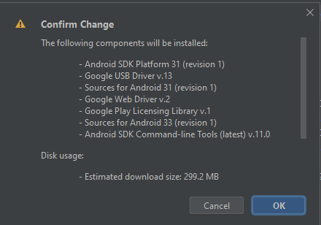

Now the components will download

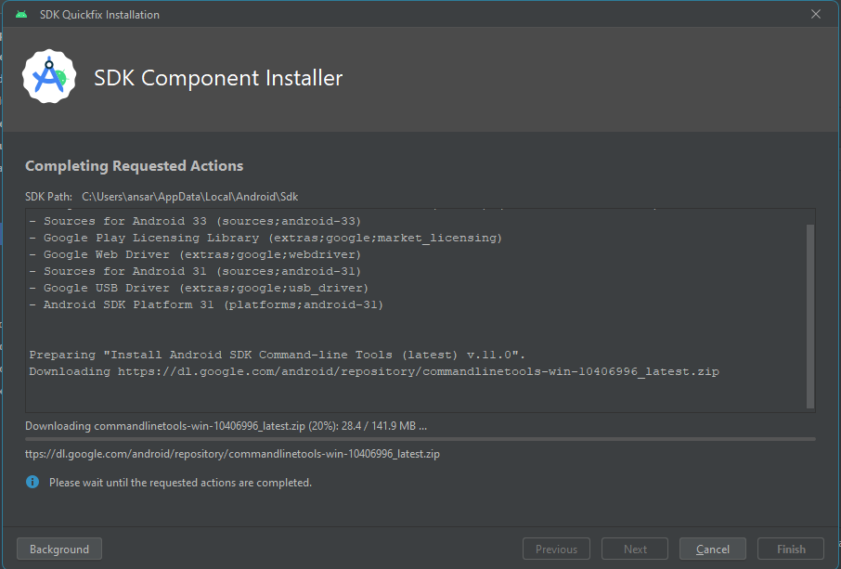

After installation complete press Ok

Step 6

Install react native and create project

Create a Folder in your path

And open cmd inside this folder

And run this command to check and install react native

>>> node -v

>>> npm -v

>>> npm config list

>>> npx -v

>>> npm install -g npx

>>> npm install -g react-native

Create react native project

>>> npx react-native@latest init FirstProject01

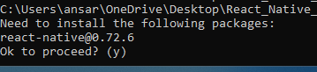

Go inside the directory



Start the application make sure android device is connected too your System



Press a in android

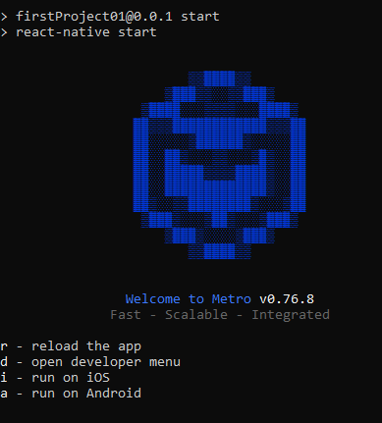

Now finish application will install in your system

Open VsCode for code editing